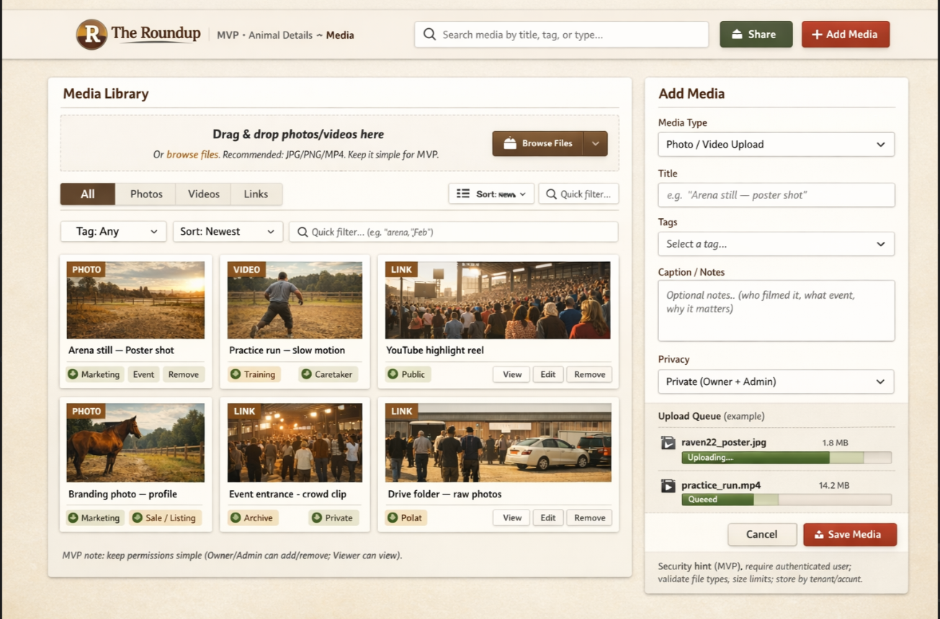 My thoughts on the media.
I hate this UI but just so you can see what I was thinking on functionality
Tagging with various items that the system already knows.
Brand ID
Location
Type (practice or completion)
Owner name
**Ability for the person to create a tag of their own
Another important tag is if it is public or private. If Private then it is only viewable by the person that uploaded it. So no other partner or owner. We can discuss the rules deeper if we need to.
One pain point they wanted to get away from was extra storage on their device for the photos that they have now. That is costing them and I wanted to be able to reduce that cost.

